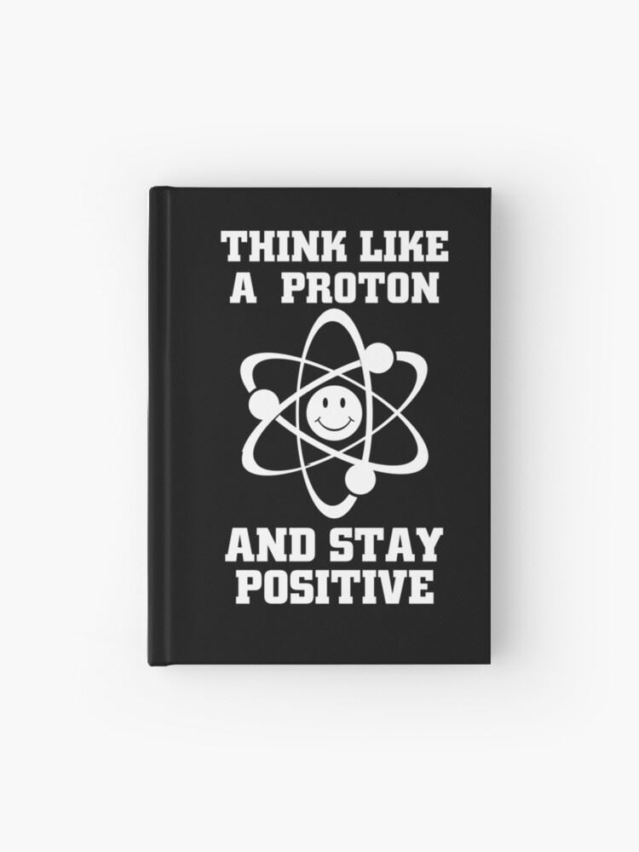**Advanced Chemistry**

**(7) Students**

**Teacher: Mr. O’Leary**

**Learning at Home**

Hello Advanced Chemistry Students!

Unfortunately we will not be in school for the remainder of the academic year. I know this is your senior year and I'm sorry that it will end this way. But this is what must be done to keep safe and look towards the future. The CLEP exam is probably not going to happen at this point, but I will keep you posted. The AP exam has been cancelled. You should by now have received your CLEP Chemistry Review Books. We will be working with these for the remainder of the academic year.

At this point (3/17) our district policy is as follows:

- You will be provided reinforcement work. I have included new concepts in the reviews and they are, of course, optional.

- Answer keys are provided for each assignment. (They are included in the review books)

- There will be no new grades entered and I will expect nothing back from you, as per school policy.

Please check my Advanced Chemistry website for videos, extra review and other curriculum related materials. Please email me if you have any questions related to our class. As always be safe and take care of yourselves.

- Mr. O'Leary

Attached are the assignments for the next weeks of Monday 5/25/2020 – Friday 6/5/2020. They are all located in the CLEP Chemistry Test Prep book you should have received by now. Your textbook will be very helpful to review concepts and provide additional review.

**Week 3**

|  |  |  |
| --- | --- | --- |
| Date | Topic | Assignment |
| Monday 5/25 | Calorimetry Lab | Go to Youtube and look up Calorimetry lab. Find an experiment you like and study a Calorimetry Lab experiment. We performed a lab with Cheetos and fritos, remember? See what other kinds of Calorimetry experiments can be completed. |
| Tuesday 5/26 | **Electron Structure of the Atom**  Wave Particle Duality and x-ray video [[WMF](https://www.forestville.com/cms/lib/NY19000591/Centricity/Domain/38/Wave_Particle_Duality_Video.asx)]  Bohr Model of the Atom Video [[WMF](https://www.forestville.com/cms/lib/NY19000591/Centricity/Domain/38/03._6.3_video.bohr_model.asx)] | Go to my website located under the Our Teachers link at Forestville.com. Today we will review the Electron Structure of the Atom. Scroll down to chapter 6 and watch these videos. |
| Wednesday 5/27 | **C6 Electron Structure of the Atom**  Online Problem Solving Center [[click](http://wps.prenhall.com/esm_brown_chemistry_8e/51/13244/3390683.cw/index.html)] | Go back to my website and click on the online problem solving center. Complete the HW reviews and quiz. You can check your answers when you are done. |
| Thursday 5/28 | **Periodic Properties of the Elements** | Go to Youtube and research the development of the Periodic Tables. Here we are looking for historical development and specifically the periodic properties of the elements. |
| Friday 5/29 | **C7 Periodic Properties of the Elements**  Go to my website located at Forestville.com under Our Teachers. | Go back to my website and click on the online problem solving center for Chapter 7. Complete the HW reviews and quiz. You can check your answers when you are done. |

**Week 4**

|  |  |  |
| --- | --- | --- |
| Date | Topic | Assignment |
| Monday 6/1 | CLEP Chemistry Review Book | Work on Diagnostic Test #3  Detailed solutions are included in the book for you to check your answers. |
| Tuesday 6/2 | CLEP Chemistry Review Book | Work on Diagnostic Test #3  Detailed solutions are included in the book for you to check your answers. |
| Wednesday 6/3 | Titration Lab | Go to Youtube and research setting up and performing a Titration experiment. Watch videos that show the method of performing a titration, the reason for the experiment and what you can learn from the experiment. There are plenty of good, short videos on the subject. |
| Thursday 6/4 | CLEP Chemistry Review Book | Work on Diagnostic Test #4  Detailed solutions are included in the book for you to check your answers. |
| Friday 6/5 | CLEP Chemistry Review Book   * We now have completed this review book. | Work on Diagnostic Test #4  Detailed solutions are included in the book for you to check your answers. |